Cyber Threat Detection Based on Artificial Neural Networks Using Event Profiles

In this project as extension I added PSO algorithm which selected relevant features from dataset and then employing SVM on PSO selected features and the calculating and comparing its accuracy with rest of the algorithms. Below screen shots code with comments in red colour explaining about PSO implementation with SVM

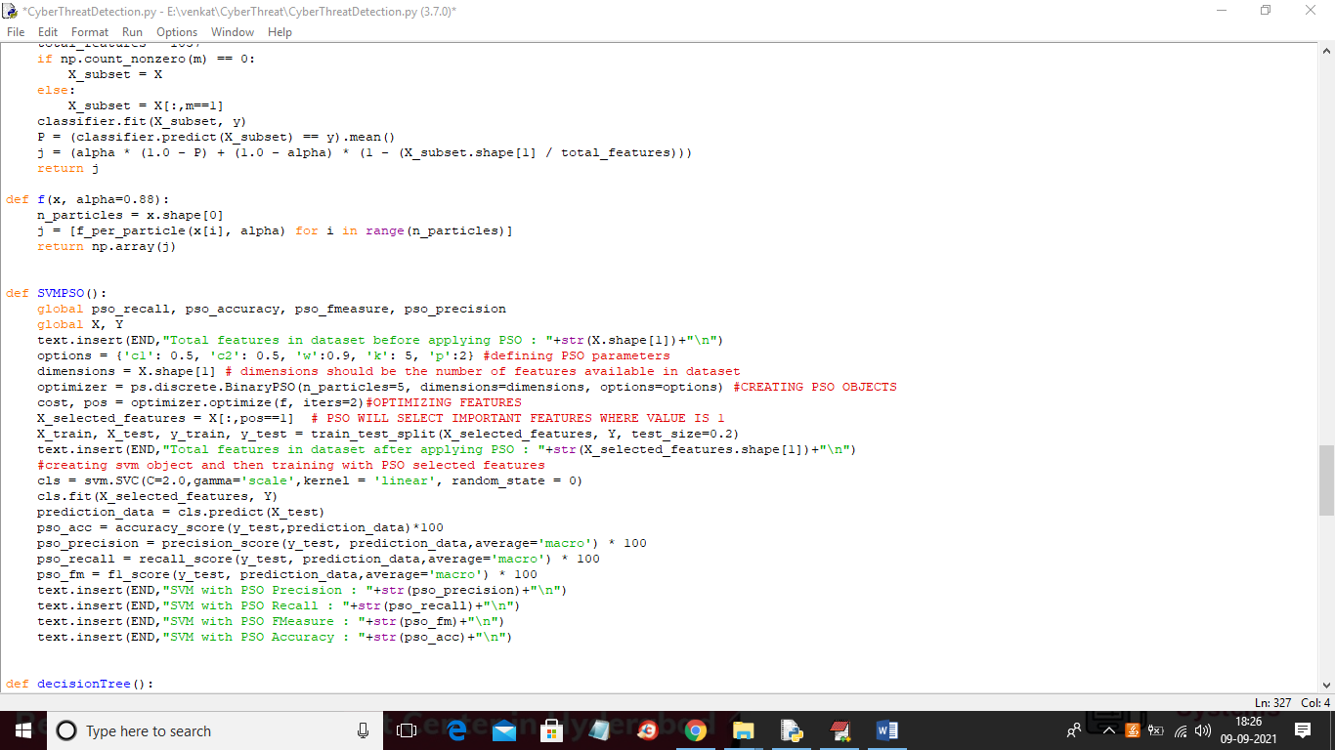

In above screen read red colour comments to know about PSO with SVM.

SCREEN SHOTS

To run project double click on ‘run.bat’ file to get below screen

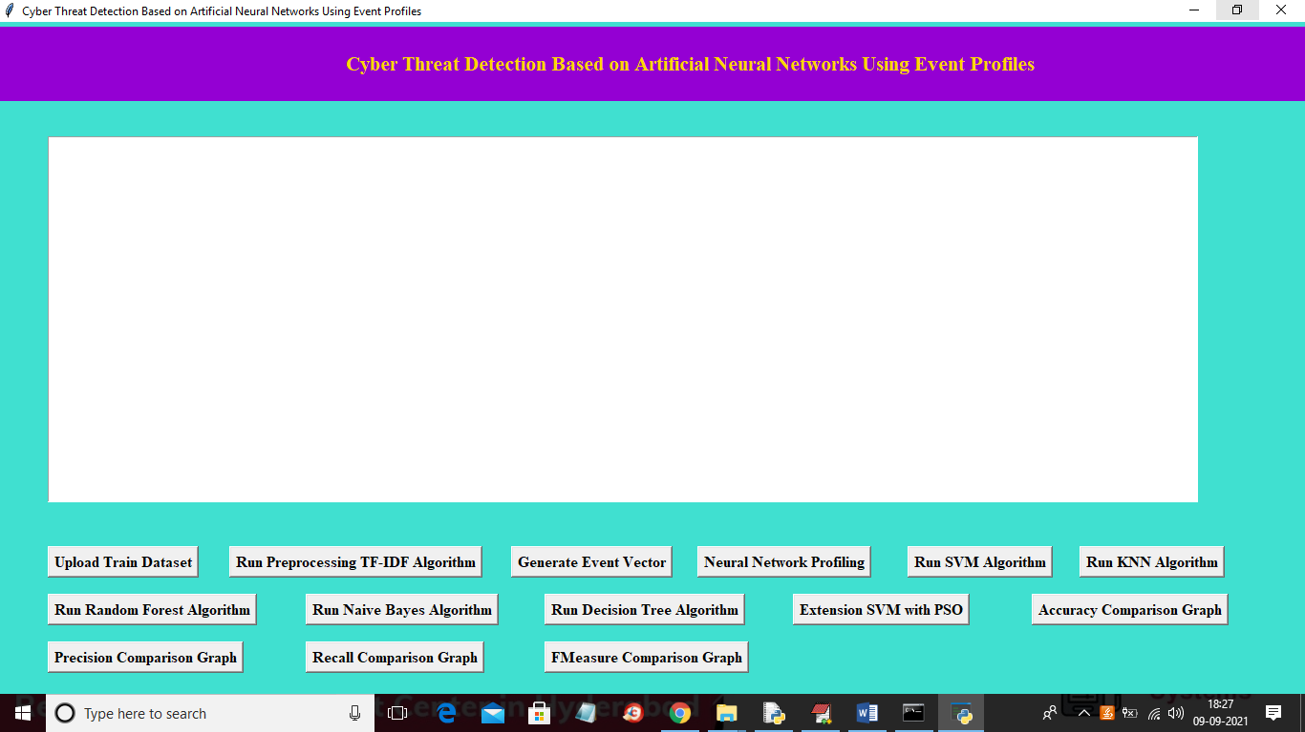

In above screen run all buttons as previous execution and I just added extra module called ‘Extension SVM with PSO’. So click each button one by one to get output

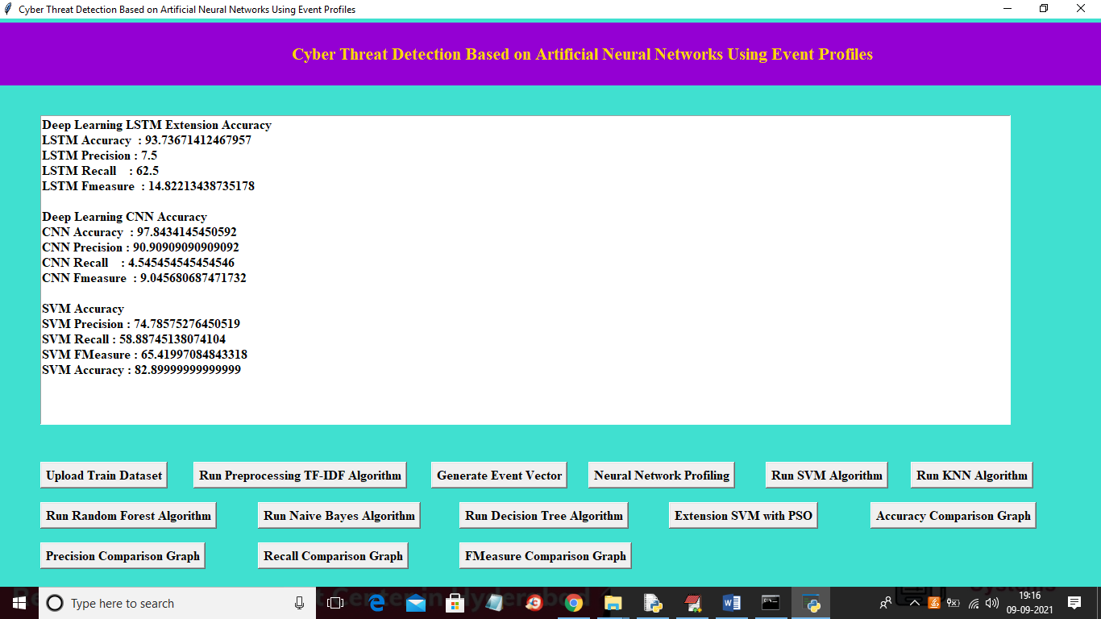

In above screen we can accuracy and other metrics for LSTM, CNN and SVM and in below screen we can see other algorithms output

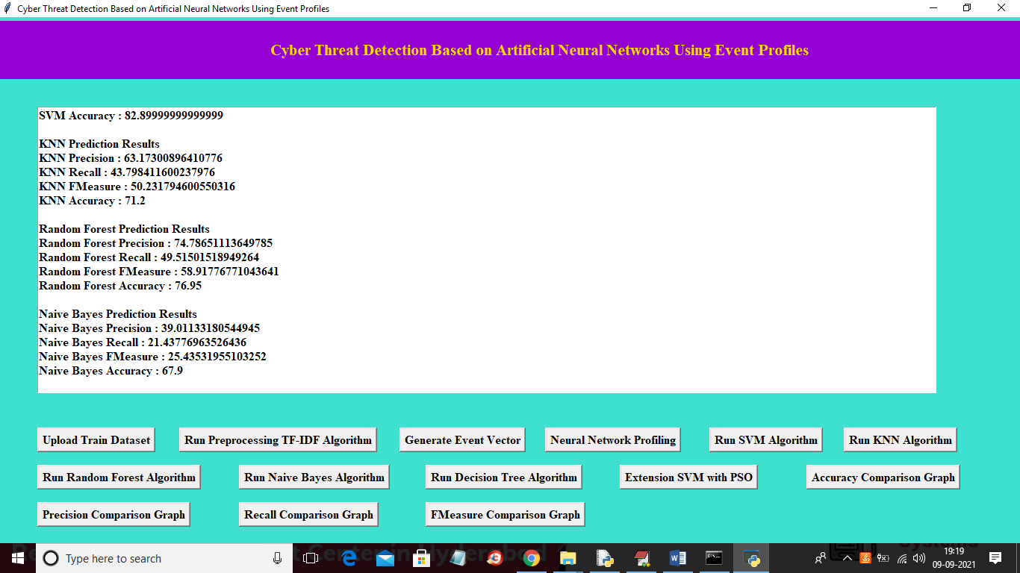

In above screen we can see result for Random Forest, Naïve Bayes and Decision Tree and now click on ‘Extension SVM with PSO’ button to get below output

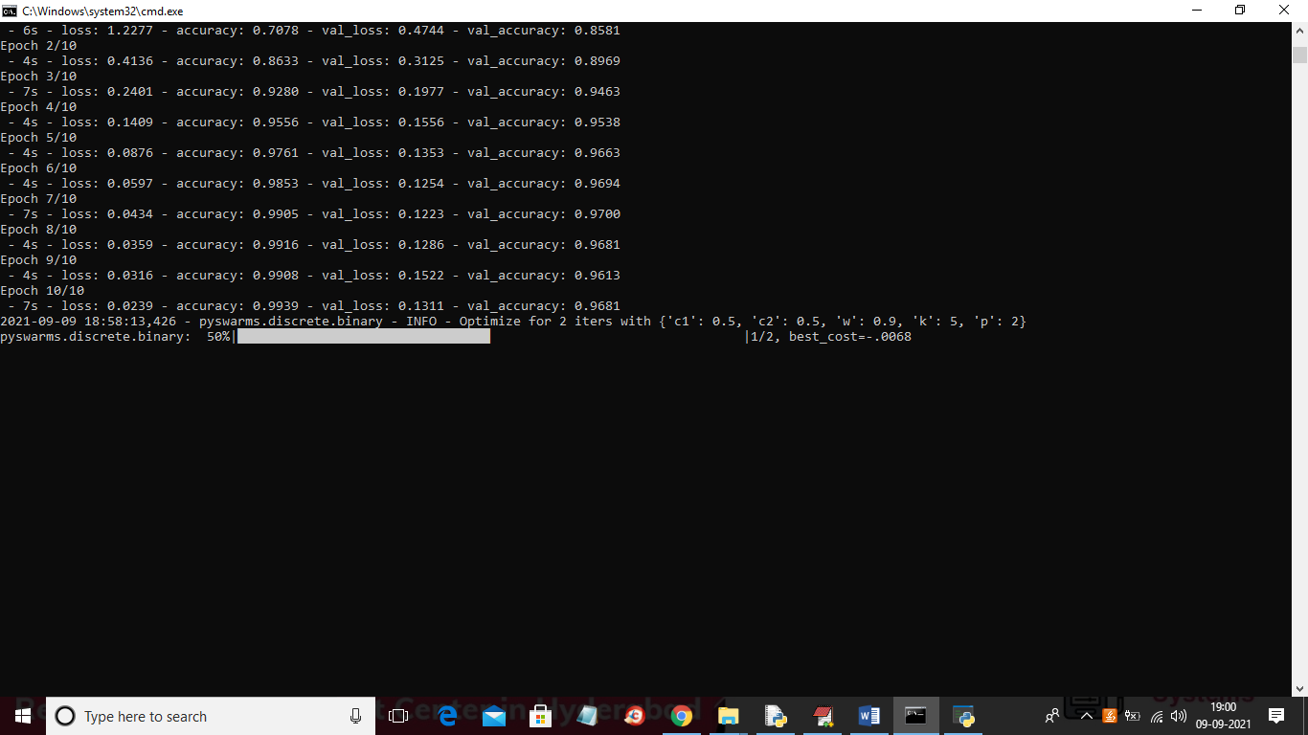

In above screen we can see PSO starts selecting important features from dataset and after that will get below output

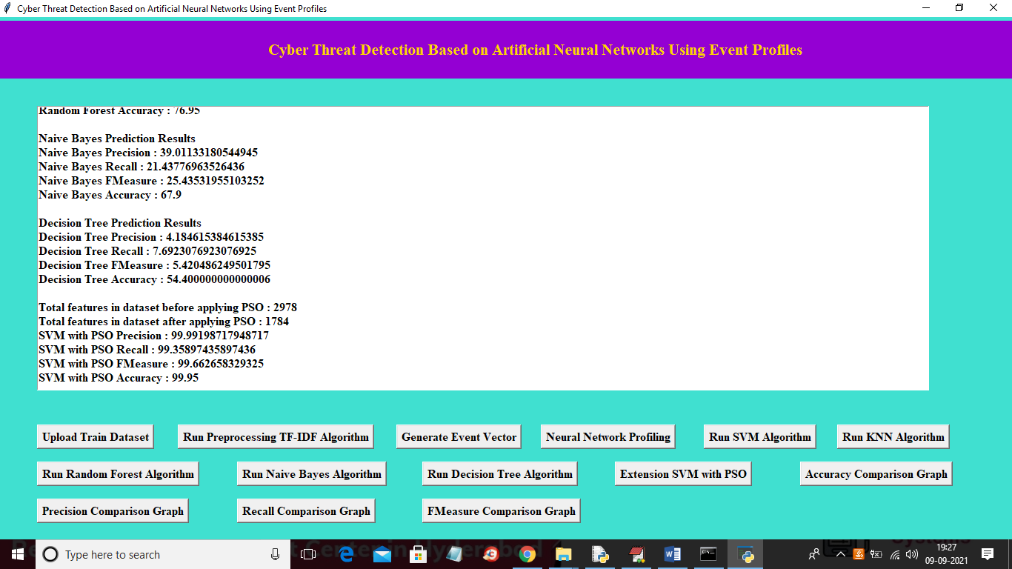

In above screen we can see result for decision tree and then we can see SVM with PSO accuracy as 99%. Now below are the performance graph

Accuracy graph

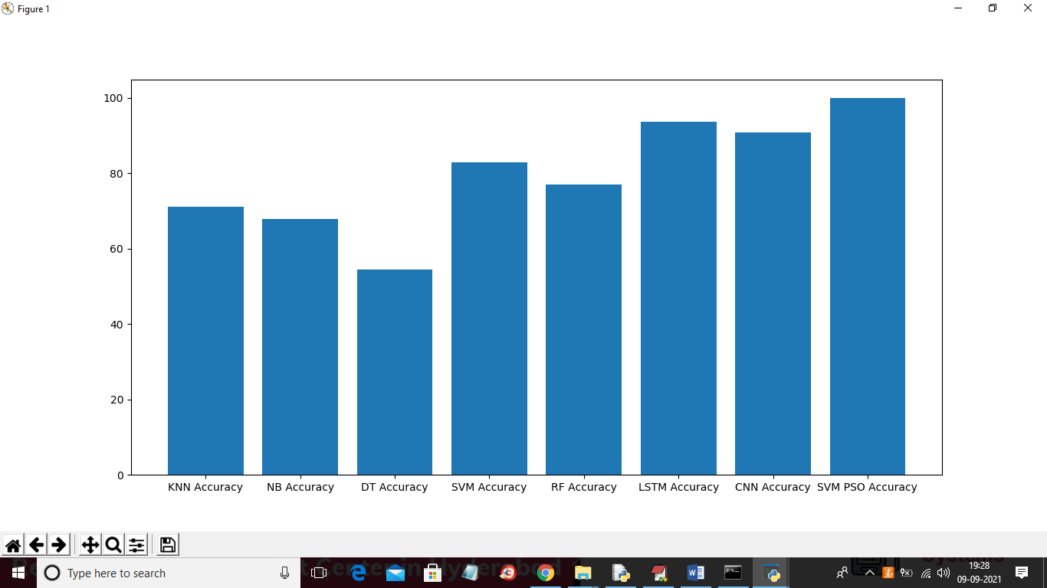

Precision graph

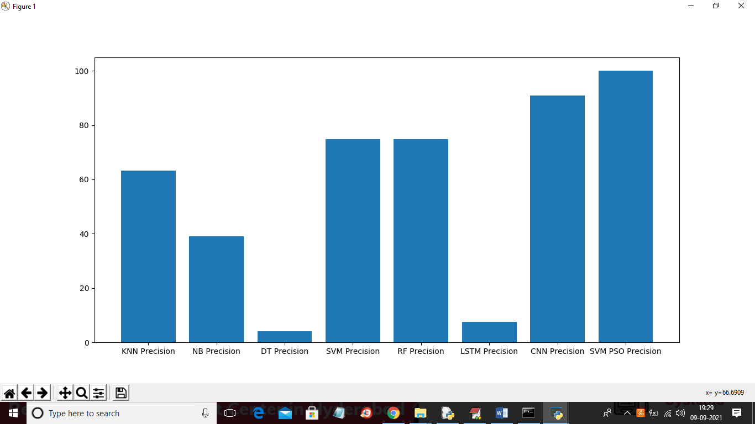

Recall graph

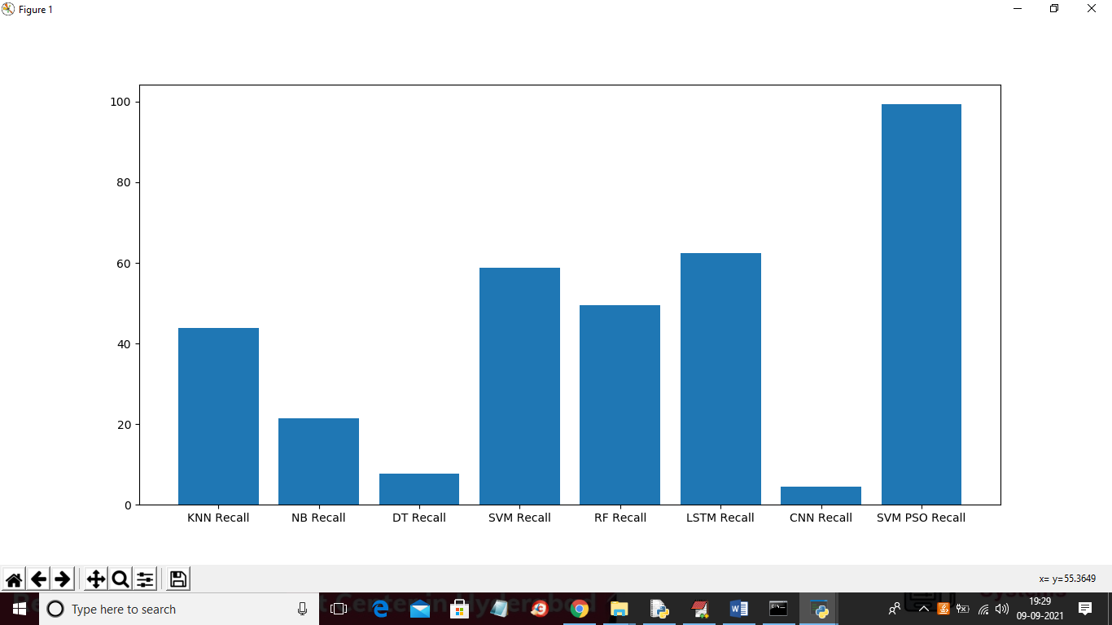

FSCORE Graph

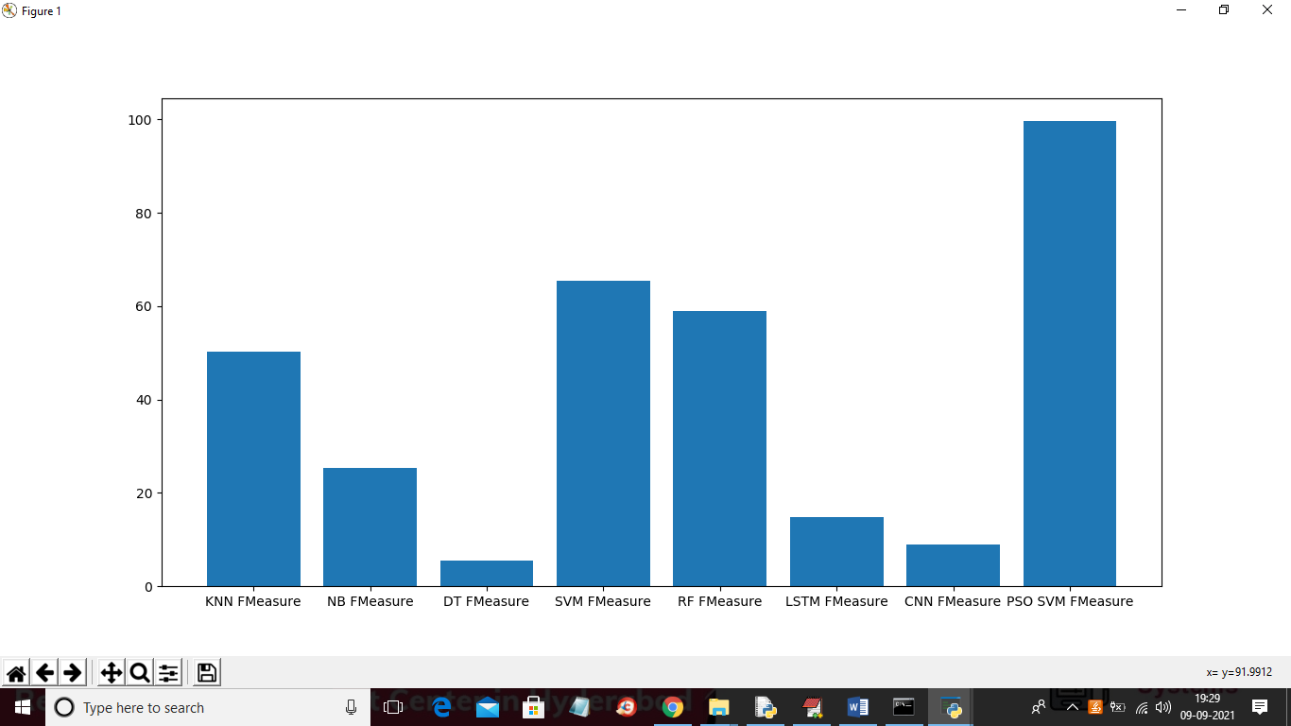

Note: due to huge dataset size execution may take long time and to complete all modules it may take 20 minutes of time